Chapter 4

Design

4.1 Entity Relationship Diagram

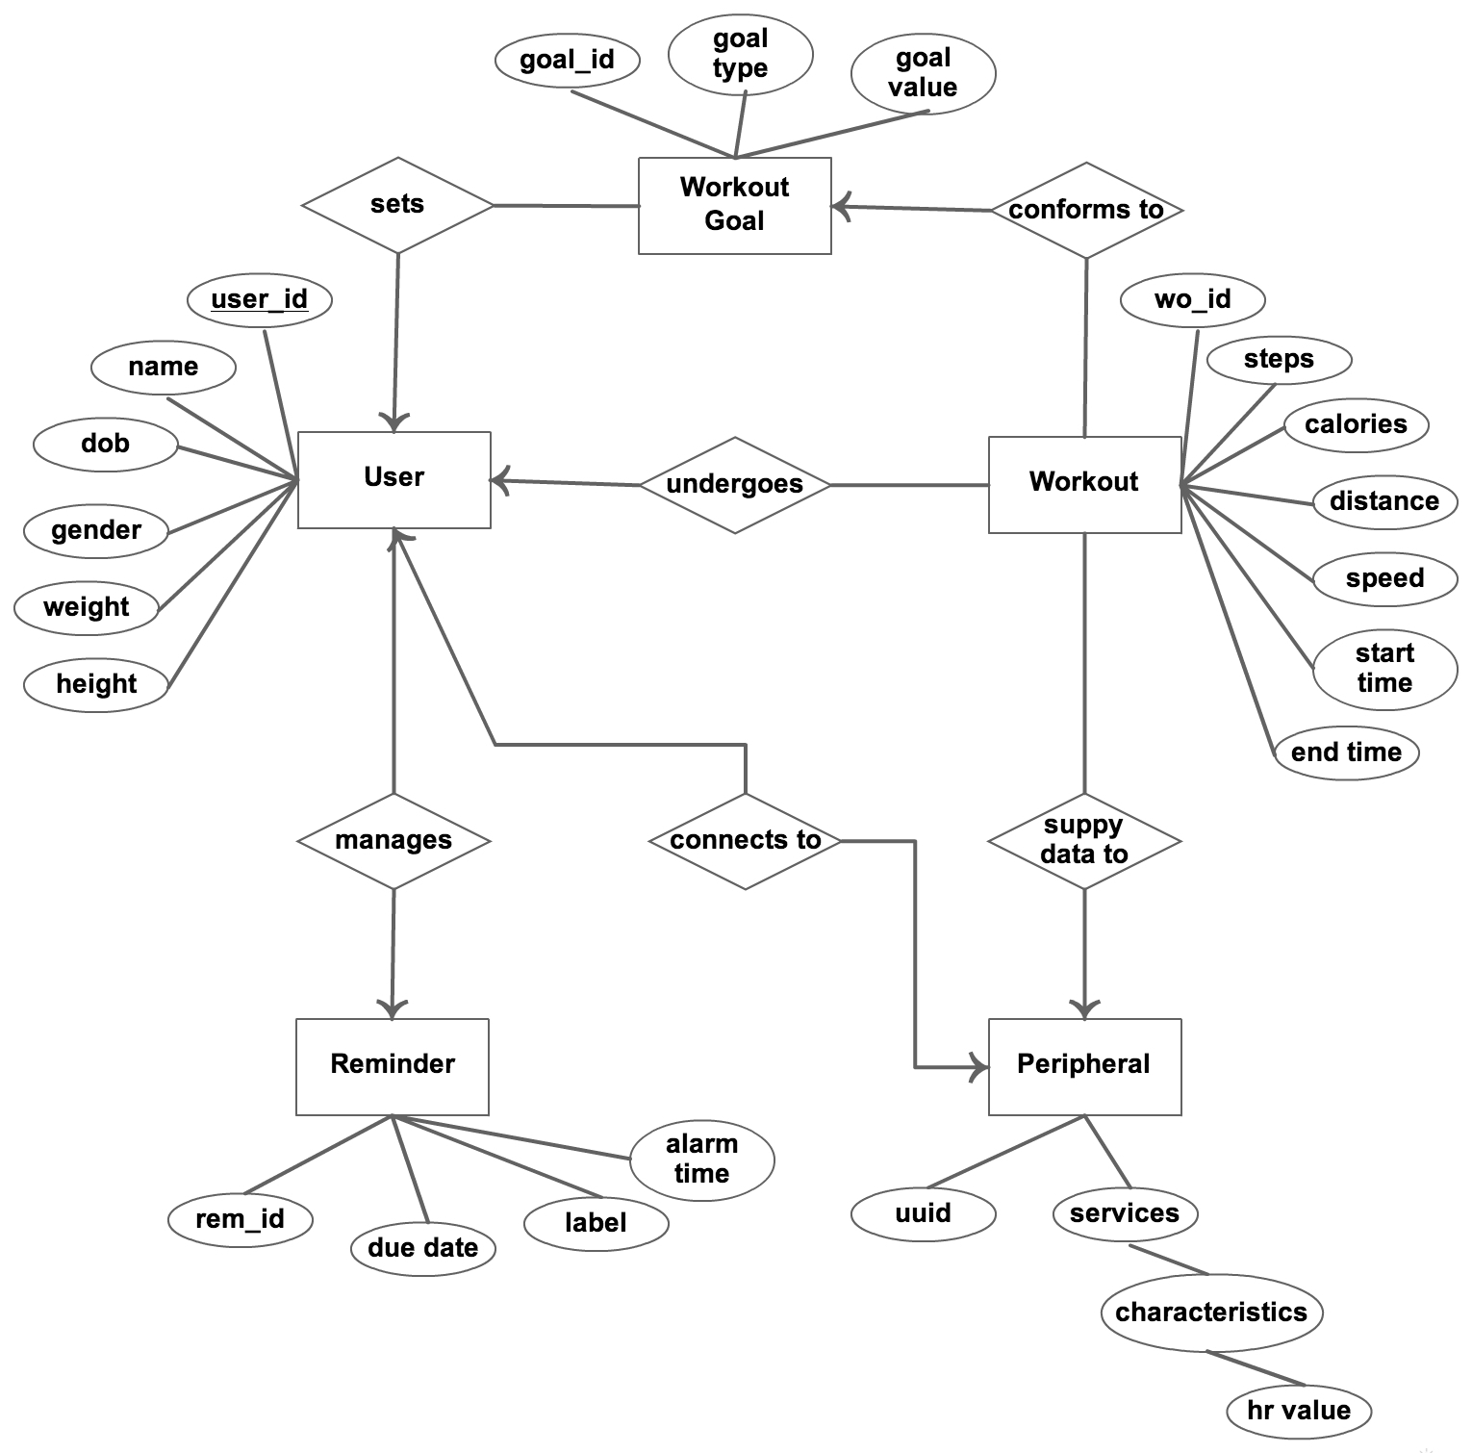

Figure 4.1 : ER Diagram

  - Data Dictionary

- TrackedObjectDetails2D - This table contains all the important information of 2D objects.
Table 4.1 : TrackedObjectDetails2D

Column Name | Data Type | Nullable | Default | Description
audioFilePath | String | Y |  | Path of Audio File of particular object.
detailDescription | String | Y |  | Object detail description.
referenceURL | String | Y |  | URL of object.
Title | String |  |  | Title of the object.
videoFilePath | String | Y |  | Path of Video File of particular object.

- TrackedObjectsDetails3D - This table contains all the important information of 3D objects.
Table 4.2 : TrackedObjecstDetails3D

Column Name | Data Type | Nullable | Default | Description
audioFilePath | String | Y |  | Path of Audio File of particular object.
detailDescription | String | Y |  | Object detail description.
referenceURL | String | Y |  | URL of object.
Title | String |  |  | Title of the object.
videoFilePath | String | Y |  | Path of Video File of particular object.

4.3 Front-end Interface, validations and navigation Design

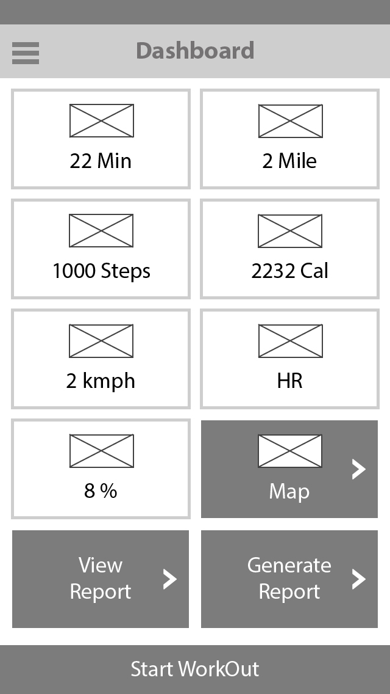

figure 1.1 : Dashboard

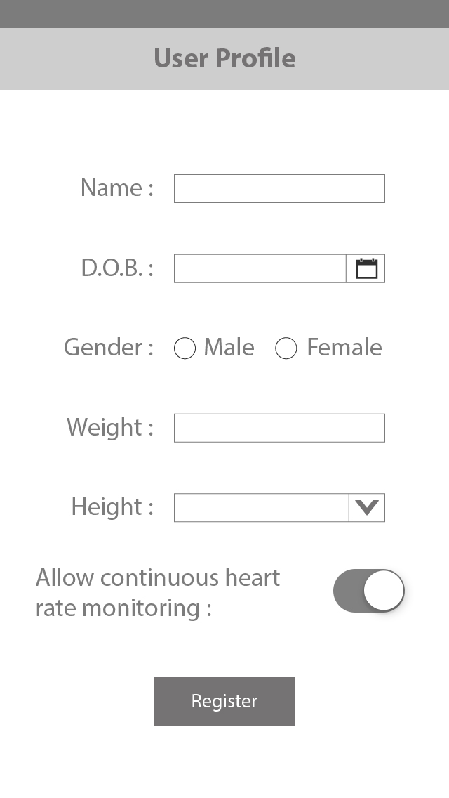
figure 1.1 : User Profile

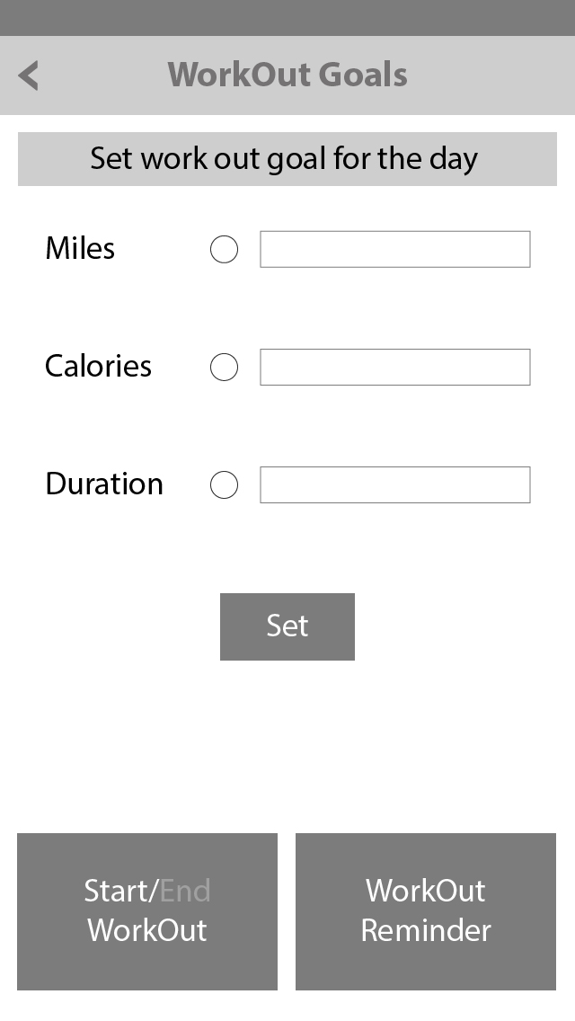
figure 1.1 : Workout Goals

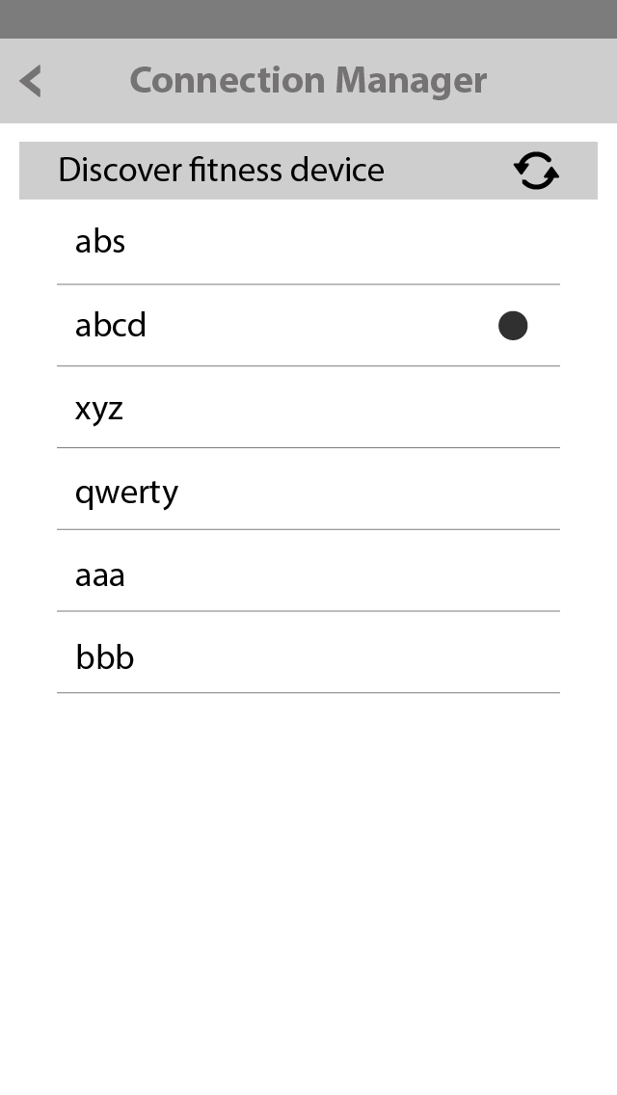
figure 1.1 : Connection Manager
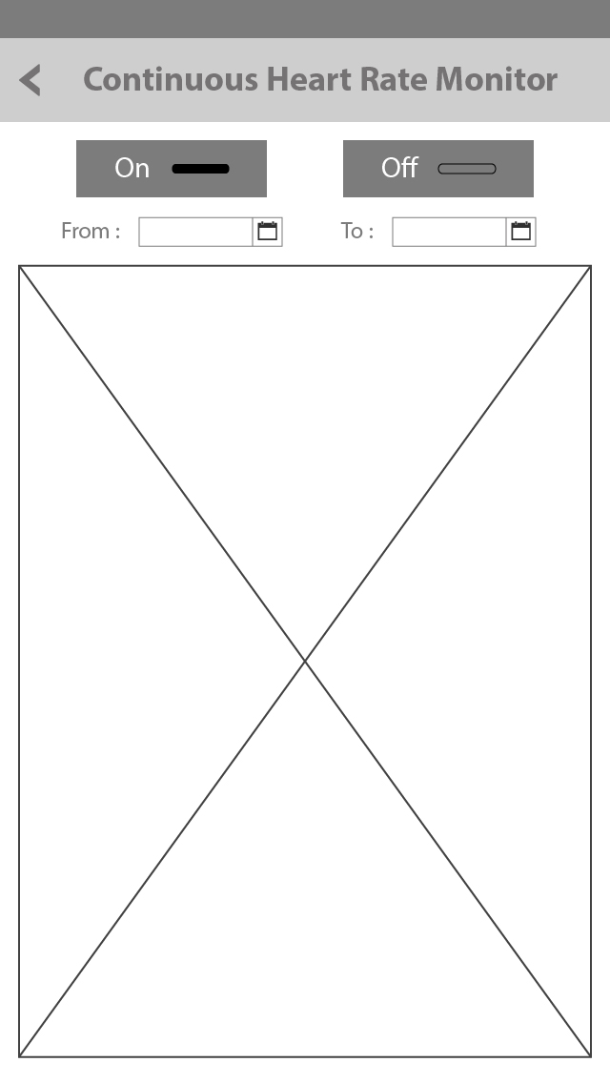

figure 1.1 : HR Monitor

